Moving from a Chain to an Ecosystem

Discussion document for CTO meeting on 5th February 2020

# Table of contents

[Context 3](#_Toc33789539)

[Goal 3](#_Toc33789540)

[Scope 3](#_Toc33789541)

[How to read 3](#_Toc33789542)

[Principles 3](#_Toc33789543)

[Roles 6](#_Toc33789544)

[Services 7](#_Toc33789545)

[Processes 9](#_Toc33789546)

[Overview 9](#_Toc33789547)

[S.1.0 Learning Application establishes relationship with Sales Agent 10](#_Toc33789548)

[S.2.0 Administrator establishes relationship between SIS, LMS and Marketplace 11](#_Toc33789549)

[OA.1.0 LMC determines LML within school 13](#_Toc33789550)

[OA.2.0 LMC provides LML to Sales Agent 15](#_Toc33789551)

[OA.3.0 Sales Agent delivers purchased products 17](#_Toc33789552)

[S.3.0 Administrator connects Learning Application, SIS and LMS 19](#_Toc33789553)

[OA.4.0 User accesses delivered products 20](#_Toc33789554)

[OA.5.0 Buyer purchases additional products during school year 22](#_Toc33789555)

[Assumptions on Technology Approach 24](#_Toc33789556)

[Glossary of terms 25](#_Toc33789557)

[Appendix A – Additional requirements Vocational Education 26](#_Toc33789558)

# Context

The Dutch foundation sBDL (foundation for improving digital learning – stichting Beter Digitaal Leren) has as primary goal that access of digital material within secondary education (in Dutch VO - Voortgezet Onderwijs) can be made easier and simpler. The foundation is a collaborating group of 8 private parties consisting of both publishers and distribution companies. Next to this foundation there is also a the EDU-K group – a group of both private and pubic organizations to optimize the services for the end-users in (Dutch) education. In lay mans terms this is sometimes referred to as the Educational Chain, to be precise it’s more an educational ecosystem, hence the title of this document.

### Goal

Within a large group of organizations there exists the wish to simplify the way all parties work together in order to deliver digital (but also) non digital content to the end-users. Within sBDL this was the reason to start an investigation both on CEO as on CTO level how this can be achieved. This document is the result of these CTO discussions.

The CEO’s of the companies (see 2019-11-01 KPMG - Versnelling vereenvoudiging leermiddelenketen) set as goal, can we come up with:

* a shared vision on the significant simplification in this chain/ecosystem.
* prerequisites and draft model/sketch on how that simplification might look like and if that is sustainable for the future.
* Make it actionable – how to realize that simplification.

### Scope

The scope is Primary Education (dutch: PO – Primair Onderwijs), Secondary Education (dutch: VO – Voortgezet Onderwijs) and Vocational Education (dutch: MBO – Middelbaar Beroepsonderwijs of Beroeps en Volwassenen Educatie). The initial focus will be Secondary Education/Vocational Education.

Expectations from the CEO’s is that first pilot can be realized in coming schoolyear 2020 – 2021.

Although a significant initial focus in this document is on digital educational material, it is not the intend to create a system that can only handle that. Some will recognize some historic reaction, the current system is actually handling digital material as physical goods. Our quest is to create such a system that can handle both digital and folio or even in a hybrid way with their own characteristics.

### How to read

For clarity of the high level solution we need to describe roles and services. However for the roles we sometimes refer already to the services, and in the services to the roles. And sometimes there is a grey area between role and service. We have chosen first to describe the roles later on we describe the services, and have added a clarifying diagram to it. It might help to take a look at the diagram while reading the roles.

# Principles

Note: the following list contains technical principles and their mutual rationale. It is far from a legal description, more to provide more context on the principle.

|  |  |
| --- | --- |
| Principle | Rationale |
| No *mandatory* central services, participants exchange information directly. Note data for a given school under the direct control of the school where appropriate | * Simplified eco-system focused around the needs of a specific school and under their control * No central infrastructure that needs to be maintained and holds back all services based on its roadmap * Simple entrance for new participants to any service * Assumes high trust between participants through transparancy |
| There can be multiple identity providers. We will use the ECK-ID to allow matching of students across them over time. Mechanisms are needed for schools and teachers | * Service providers (such as SIS vendors) are an ideal source of identity for schools, and can be relied upon within a schools ecosystem. Note a SIS is not equal to an IdP * Services such as those provided by Kennisnet can also be used, though are not strictly required |
| Business model agnostic; can support pre-pay (transactional or subscription), freemium or usage based post-pay | * While optimized for school start based on a LML, it can support other models * Flexibility for participants to offer products under any model they choose via any route they choose |
| Based on a set of clear services that anyone can choose to provide to the ecosystem, and a single company may provide one or more services | * No central control point that inhibits any single company (or small group) from controlling the ecosystem and stifling innovation * Freedom to compete in the provision of any service * Data is shared directly between services and can be cached for performance and reliability * Each service is responsible for its own redundancy and reliability |
| Schools will be free to choose any services | * Schools have the choice to use multiple providers for each service based on what suits their needs * Schools should be able to add / remove services during the school year |
| Data will always be provided from the source, and not passed between services. It is always clear who is responsible for the data and that it is provided in a transparent way | * Services can rely on data being correct and timely to avoid manual administration by schools * Innovation can happen on top of services that schools have already invested in * Data should be exchanged on “need to know basis”, and binded to the purpose (goal binding/GDPR requirement or doelbinding/AVG eis) Data will be exchanged based on minimum required for delivery of services and data privacy |
| Not have administration in the lead, always ensure access is possible | * Ensure that users are always able to access material where they are entitled to. * No stock levels for digital products |
| Need to be closed money goods flow | * Usage of ‘goods’ means that money is/needs to be transferred to the one who is providing. |

# 

# Roles

|  |  |  |
| --- | --- | --- |
| Role | Example Types | Description |
| **User** | Student  Teacher | An individual, or member of an organisation, who is a user of a service provided by participants in the eco-system, this may or may not be connected to a purchase having occurred previously (either pre or post pay). |
| **Buyer** | Student (VO+)  Teacher  Parent  LMC | An individual, or representative of an organisation who they are purchasing on behalf of, who is the buyer of Learning Material via a Marketplace. |
| **Administrator (SIS)** | Administrator | An individual who is responsible for the maintenance of data stored within a SIS. |
| **LMC** | Leermiddelen coordinator (Learning Materials Coordinator) | An individual responsible for collating the needs of the teachers across departments in a school, and creating the list of material (mandatory and optional) that is then ordered for the school for a given school year. |
| **LML** | Leermiddelen Lijst  (Learning Material List) | A composed list of learning materials intended for a specific course, group, class |
| **Learning Materials Provider** | Publisher  EdTech Company  Teacher | An individual or organisation who provides learning materials for use both inside and outside the classroom, this can be either via folio or accessed via a digital Learning Application (provided either by the same company or a different one). |
| **Learning Management Provider** | Publisher  EdTech Company | An organisation that provides tools to schools to enable them to effectively manage scheduling of learning (typically this is referred to as an LMS or an ELO). |
| **Sales Agent** | Distributor  Retailer  Publisher  EdTech Company | An organisation that provides services for schools to order Learning Materials. |
| **Fulfilment Agent** | Distributor  Publisher  EdTech Company  School | An organisation that takes responsibility for the fulfilment of Learning Material to an individual student or to a school, either through physical delivery or via delivery to the LMS in use within the school or directly to the individual (e.g. via email). Note a school can also provide material to its students. |
| **SIS**  **Provider** | EdTech Company | is a management information system for education establishments to manage student data. Student information systems provide capabilities for registering students in courses; documenting grading, transcripts, results of student tests and other assessment scores; building student schedules; tracking student attendance; and managing many other student-related data needs in a school  This system is the source of the ECK-ID |

# Services

Services are provided to support the roles in carrying out the processes. The services communicate directly with each other, under the direction and control of the school (where appropriate). Note that schools can select multiple of these services, so multiple Learning Applications, multiple Learning Management Systems, multiple Marketplaces and even multiple School Information Systems. Next to that schools can also omit one or more of these services. In theory the smallest set might be a single Marketplace and a single Learning Application.

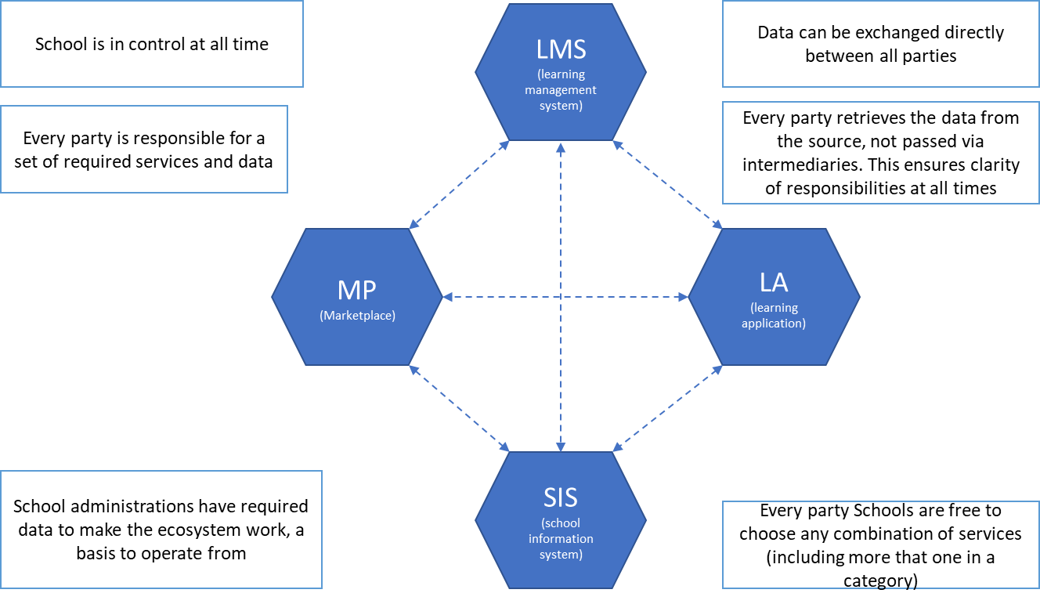

|  |  |
| --- | --- |
| Service | Description |
| **Marketplace (MP)** | A service that allows buyers to order, and then have delivered, learning materials (physical and digital) via either a LML (for start school year) or at any time of the year either at school level or via students / parents. A school can contract with multiple marketplaces if desired. |
| **Learning Management System (LMS)** | A service that allows users to schedule and manage the learning material that is assigned to students. The Learning Management system can be populated with learning material that is selected or purchased from a Marketplace. |
| **Learning Application (LA)** | A service that allows for the delivery of a specific learning activity in a digital environment and subject. This service is typically accessed via a Learning Management system but can also be accessed directly. |
| **School Information System (SIS)** | A service that allows an administrator to manage the core data that the school needs to operate: students, teachers, subjects, streams and classes. This data is then provided (at the minimum level required and under the control of the school) to other services to allow them to function efficiently. The SIS is the source of the ECK-ID |
| **Identity Provider (IdP)** | A service that provides Identity information about both students and teachers to the other services in the ecosystem. This includes the ECK-ID as base for other associated data as needed (e.g. the students initials or class information). The IdP is not shown in the above diagram and not equal to the SIS service |

# 

# 

# Processes

There will be a significant number of processes that need to be defined over time, dealing with each possible path in the journey from selection through to usage. For this stage we will focus on the critical paths required to prove that the new model can work, and as we work through any pilot and implementation we will identify and then expand on the other processes required.

In addition, these processes will focus on the interactions between services, not on functions that can be provided within a specific service (for example - while we show how information from a Learning Application (LA) can be passed to the Learning Management System (LMS) to provide feedback on progress, this does not mean that the Learning Application does not also have functionality to provided detailed insights and analysis on learner progress).   
Note in the following descriptions we are using the term API this can be read as both synchronize and a-synchronize interoperability.

We assume somewhere somehow commercial relationships have been established.

The processes are grouped:

* **S** - Setup processes, these are typically performed occasionally (e.g. once per relationship that needs to be established between services), and would be carried out typically by an Administrator in order to e.g. provide consent on data that is passed from on service to another.
* **OA** - Order and Access related processes, these are the core flows that result in the delivery and then usage of a Learning Application.

Note we didn’t provide a complete overview of the data that needs to be provided or will be returned in all described processes. Further elaboration needs to be provided during a working POC..

# Overview

[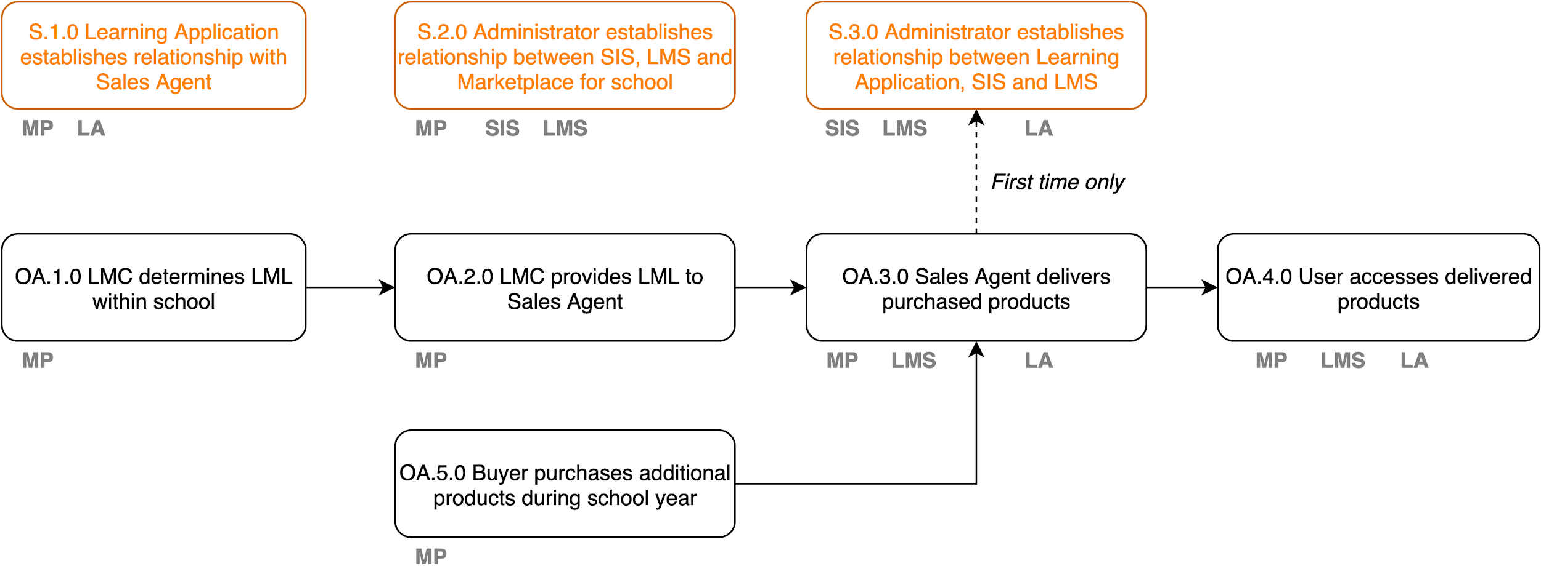](https://www.draw.io/?page-id=e7e014a7-5840-1c2e-5031-d8a46d1fe8dd&scale=auto#G1DCkdewm8oO_kXXFjzAph-oT4X4u0k6Ig)

For each process area there will be a high level flow diagram, and then for each step a summary of pre-requisites, input and outputs.

# S.1.0 Learning Application establishes relationship with Sales Agent

Establish the connections between the Marketplace and the Learning Applications to allow content and applications to be purchased.

[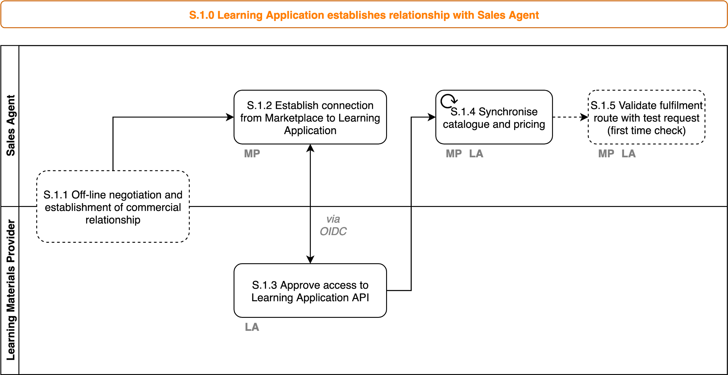](https://www.draw.io/?page-id=rhrGl-8aHOkGDUDg3F7p&scale=auto#G1DCkdewm8oO_kXXFjzAph-oT4X4u0k6Ig)

|  |  |  |  |
| --- | --- | --- | --- |
| **Step** | **Pre-requisites** | **Input Data** | **Output Data** |
| **S.1.1** |  |  |  |
| **S.1.2** | Marketplace allows a Sales agent administrator to create a connection to a learning application. |  |  |
| **S.1.2** | Learning Application provides an API for catalogue and fulfilment that allows access token provisioning via e.g. OIDC. | Partner Account | API Token |
| **S.1.3** |  | API Token | LA Catalogue  LA Catalogue Pricing |
| **S.1.4** |  | API Token  Fulfilment Request | Fulfilment Response |

# S.2.0 Administrator establishes relationship between SIS, LMS and Marketplace

Establish the connections between the LAS, the Marketplace and the LMS used within a school (done only when these systems change or new services are added). Note this is three separate processes grouped together below for simplicity.

|  |  |  |  |
| --- | --- | --- | --- |
| **Step** | **Pre-requisites** | **Input Data** | **Output Data** |
| **S.2.1** |  |  |  |
| **S.2.2** | Marketplace allows a Sales agent administrator to create a connection to a SIS. |  | API Token Request |
| **S.2.2** | SIS allows an administrator to approve a request for API access. | API Token Request | API Token |
| **S.2.3** | Marketplace can retrieve data from SIS. |  | Groups  Streams  Subjects  (Note, needs to be aligned with EduStandaard definitions) |
| **S.2.4** | Marketplace allows a sales agent to create a connection to a schools LMS |  | API Token Request |
| **S.2.5** | LMS allows an administrator to approve access. | API Token Request | API Token |
| **S.2.6** | LMS allows an administrator to create a connection to a SIS. |  | API Token Request |
| **S.2.7** | SIS allows an administrator to approve a request for API access. | API Token Request | API Token |
| **S.2.8** | LMS can retrieve data from SIS. |  | Groups  Streams  Subjects  Teachers  Students |

### 

# OA.1.0 LMC determines LML within school

The process by which the LMC determines the material available to be used during the school year (mandatory and optional). Note the iterative process of creating an LML is not described and provided as a given here.

[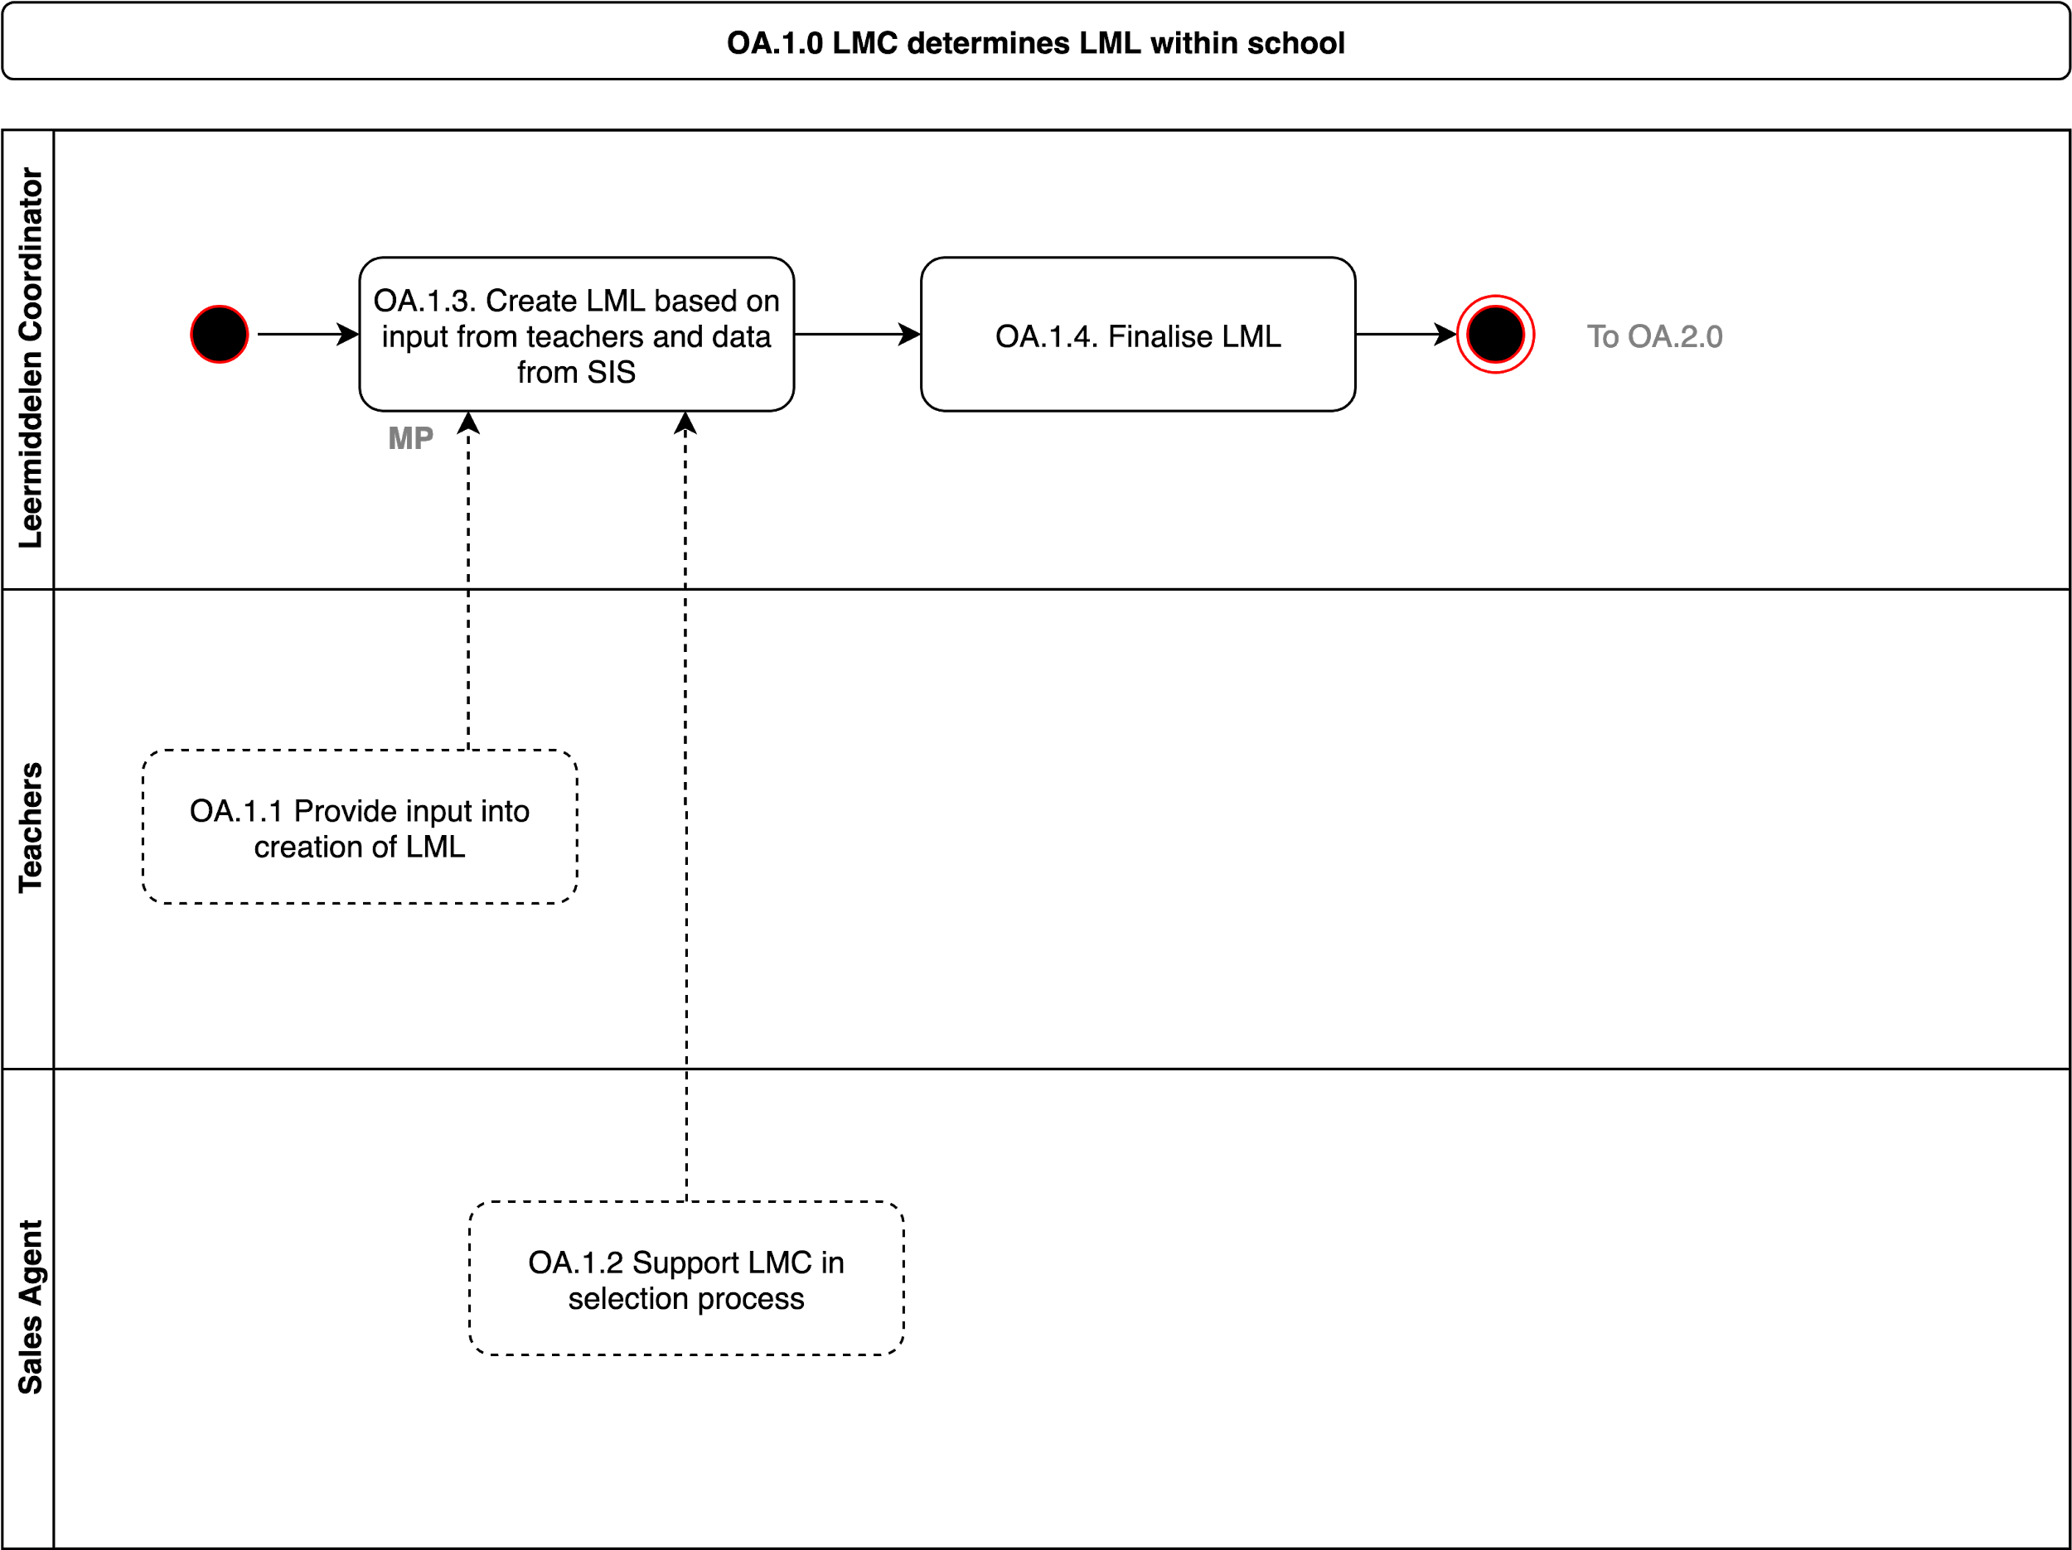](https://www.draw.io/?page-id=zTflHKT45aISA6j684Mk&scale=auto" \l "G1DCkdewm8oO_kXXFjzAph-oT4X4u0k6Ig)

|  |  |  |  |
| --- | --- | --- | --- |
| **Step** | **Pre-requisites** | **Input Data** | **Output Data** |
| **OA.1.1** | Teachers have visibility of possibly available material. | School Catalogue (i.e. the catalogue selected for a school) |  |
| **OA.1.2** | Sales agent can provide services to support the LMC | School Catalogue  Classes  Courses  Streams |  |
| **OA.1.3** | Marketplace provides tools to enable the LMC to manage the LML. | School Catalogue  Classes  Courses  Streams | Work in process School LML |
| **OA.1.4** | When complete the Marketplace allows the LMC to finalise the list. Note that the LML is not at student level at this stage, but attached to groups the students will later be added to in the SIS. | WIP School LML | Finalised School LML |

### 

# OA.2.0 LMC provides LML to Sales Agent

Submission of the LML as a selection of material that can be used during the school year, under any possible payment model. This process is focused on Secondary and EBF at this stage (other processes will exist for Vocational and IBF that can be expanded on later).

|  |  |  |  |
| --- | --- | --- | --- |
| **Step** | **Pre-requisites** | **Input Data** | **Output Data** |
| **OA.2.1** |  | Finalised School LML | Submitted School LML (pending on contract details this can have impact on commercial terms) |
| **OA.2.2** | The marketplace can take the submitted LML and create orders for each student (based on SIS data), this enables confirmation of delivery and selection of optional material. This is based on which groups the student is a member of in the SIS and should require no administration. | Ordered School LML | Draft Personal Order |
| **OA.2.3** | Student or parent can receive notification via email, app or other mechanism. | Order Notification |  |
| **OA.2.4** | Marketplace allows student to login and confirm their order. | Draft Personal Order | Submitted Personal Order |
| **OA.2.5** | Marketplace can update the LML and pass the information on to fulfilment agents. | Submitted Personal Order(s) | Submitted School LML |

### 

# OA.3.0 Sales Agent delivers purchased products

The sales agent delivers the products purchased through physical delivery, or integration with the LMS and LA to ensure that a personalised list can be created for each student and teacher. At this stage the digital delivery can be at group level (e.g. class, course, stream) so as students arrive or change through before (or during) the school year the digital material should always be available to them. If there are limits (e.g. 30 licenses sold and 31 students now in a group) then the decision is up to the Learning Application Provider if they allow access. Note on a pre-paid situation the delivery can still be on student level.

[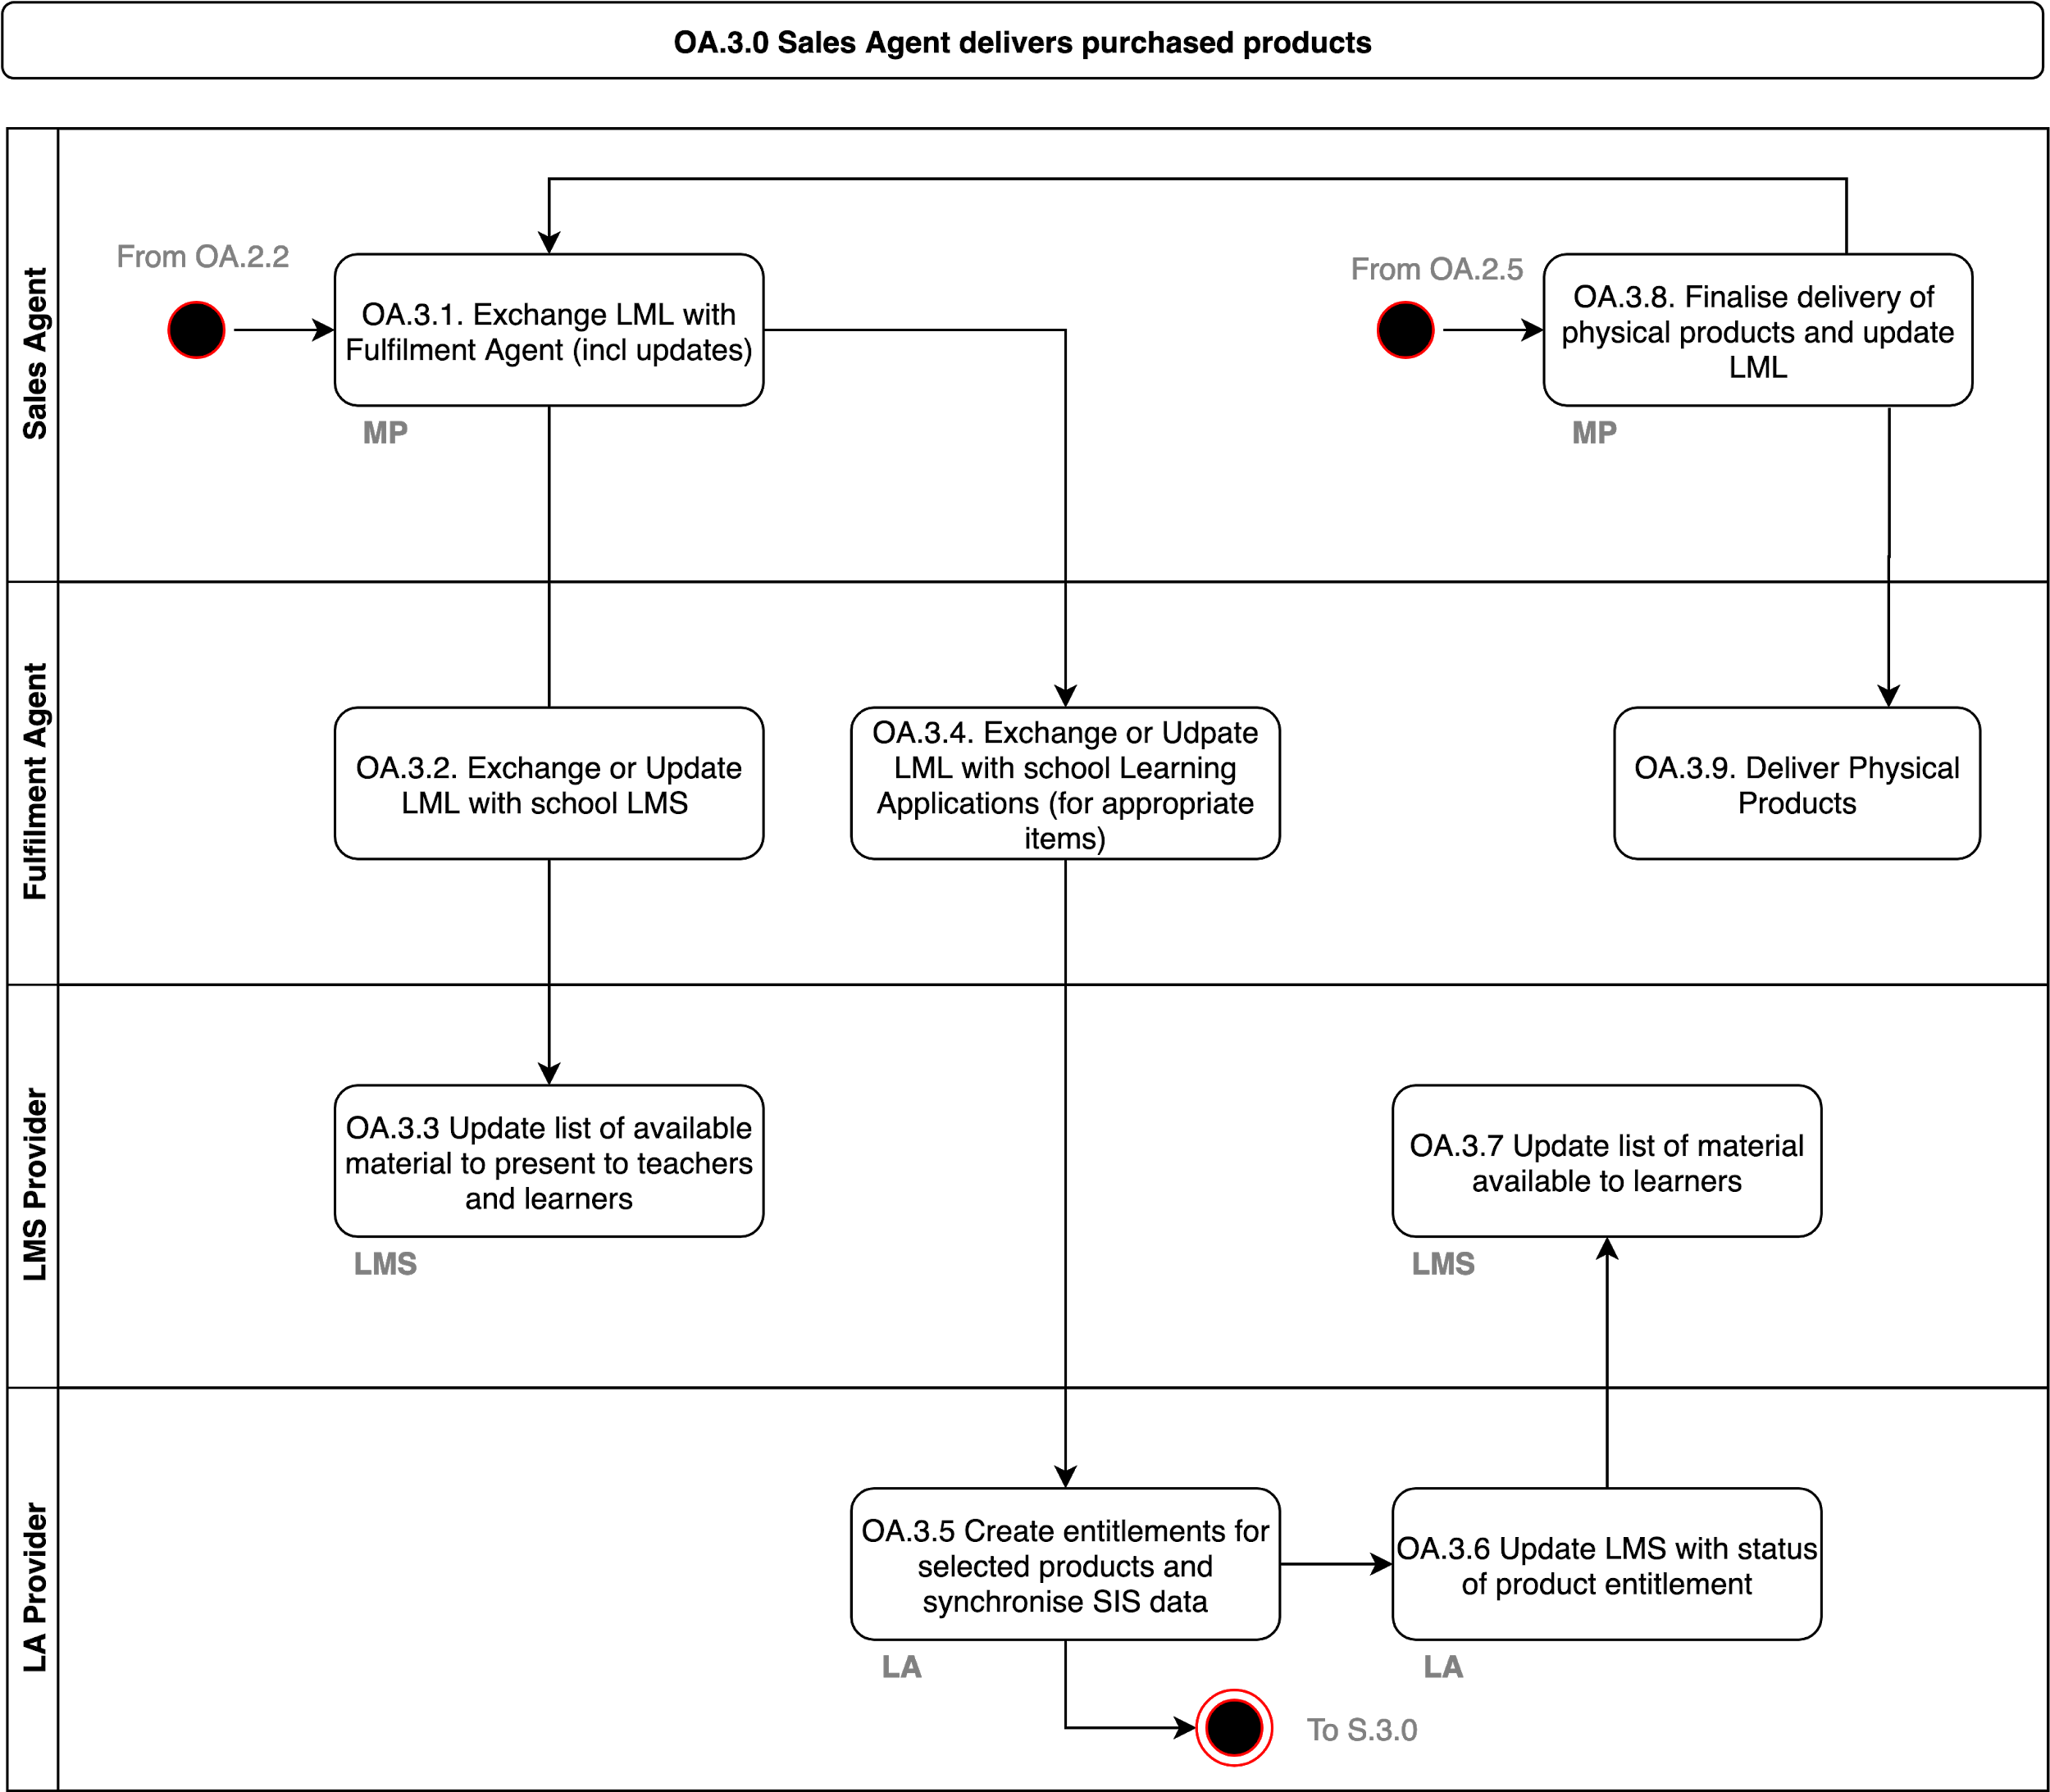](https://www.draw.io/?page-id=hN4-7act3WtkMmFALBDE&scale=auto" \l "G1DCkdewm8oO_kXXFjzAph-oT4X4u0k6Ig)

|  |  |  |  |
| --- | --- | --- | --- |
| **Step** | **Pre-requisites** | **Input Data** | **Output Data** |
| **OA.3.1** | The marketplace can pass on the LML to a Fulfilment agent so that it can be fulfilled |  | School LML |
| **OA.3.2** | The Fulfilment Agent ensures that the LMS and Learning Applications receive the LML | School LML | School LML |
| **OA.3.3** | The LMS can use the information from the LML to create a personalised learning list for each user based on information from the SIS (Class, Group etc). | School LML | Personalised Learning Materials List |
| **OA.3.4** | The marketplace can pass on the LML to the Learning Applications (for their products) to enable the LA to provision the entitlements and establish connections to the schools systems. |  | School LML |
| **OA.3.5** | The Learning Application uses the information in the LML to create entitlements, and trigger the S.3.0 process to connect the application to the schools SIS and LMS if needed. | School LML | Entitlements |
| **OA.3.6** | The Learning Application provides updated information on fulfilment to the LMS. |  | Fulfilment Confirmation (i.e. ready to fulfil) |
| **OA.3.7** | The LMS can update the status of the products to indicate they can now be used. | Fulfilment Confirmation | Updated Personalised Learning Materials List |
| **OA.3.8** | As the marketplace gets updates based on personal selections (e.g. optional material) this may trigger further communication to the Learning Applications | School LML | Personalised Learning Materials List |
| **OA.3.9** | The Fulfilment Agent ensures delivery of any physical materials. |  |  |

### 

### 

# S.3.0 Administrator connects Learning Application, SIS and LMS

[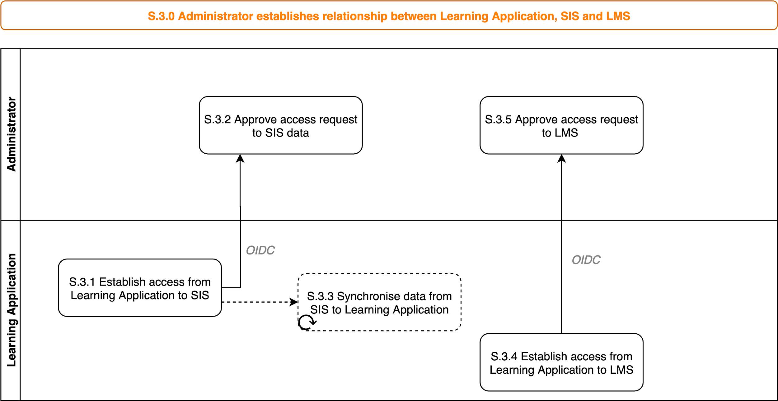](https://www.draw.io/?page-id=9IBW5L8doE-CgJIbAMNC&scale=auto" \l "G1DCkdewm8oO_kXXFjzAph-oT4X4u0k6Ig)

|  |  |  |  |
| --- | --- | --- | --- |
| **Step** | **Pre-requisites** | **Input Data** | **Output Data** |
| **S.3.1** | Learning application can request access to data from the SIS |  | API Token Request |
| **S.3.2** | SIS can approve access to API | API Token Request | API Token |
| **S.3.3** | Learning application can synchronise needed data from the SIS |  | Groups  Classes  Streams  Teachers  Students |
| **S.3.4** | Learning application can request access to the API from the LMS |  | API Token Request |
| **S.3.5** | LMS Administrator can approve access to API | API Token Request | API Token |

### 

# OA.4.0 User accesses delivered products

[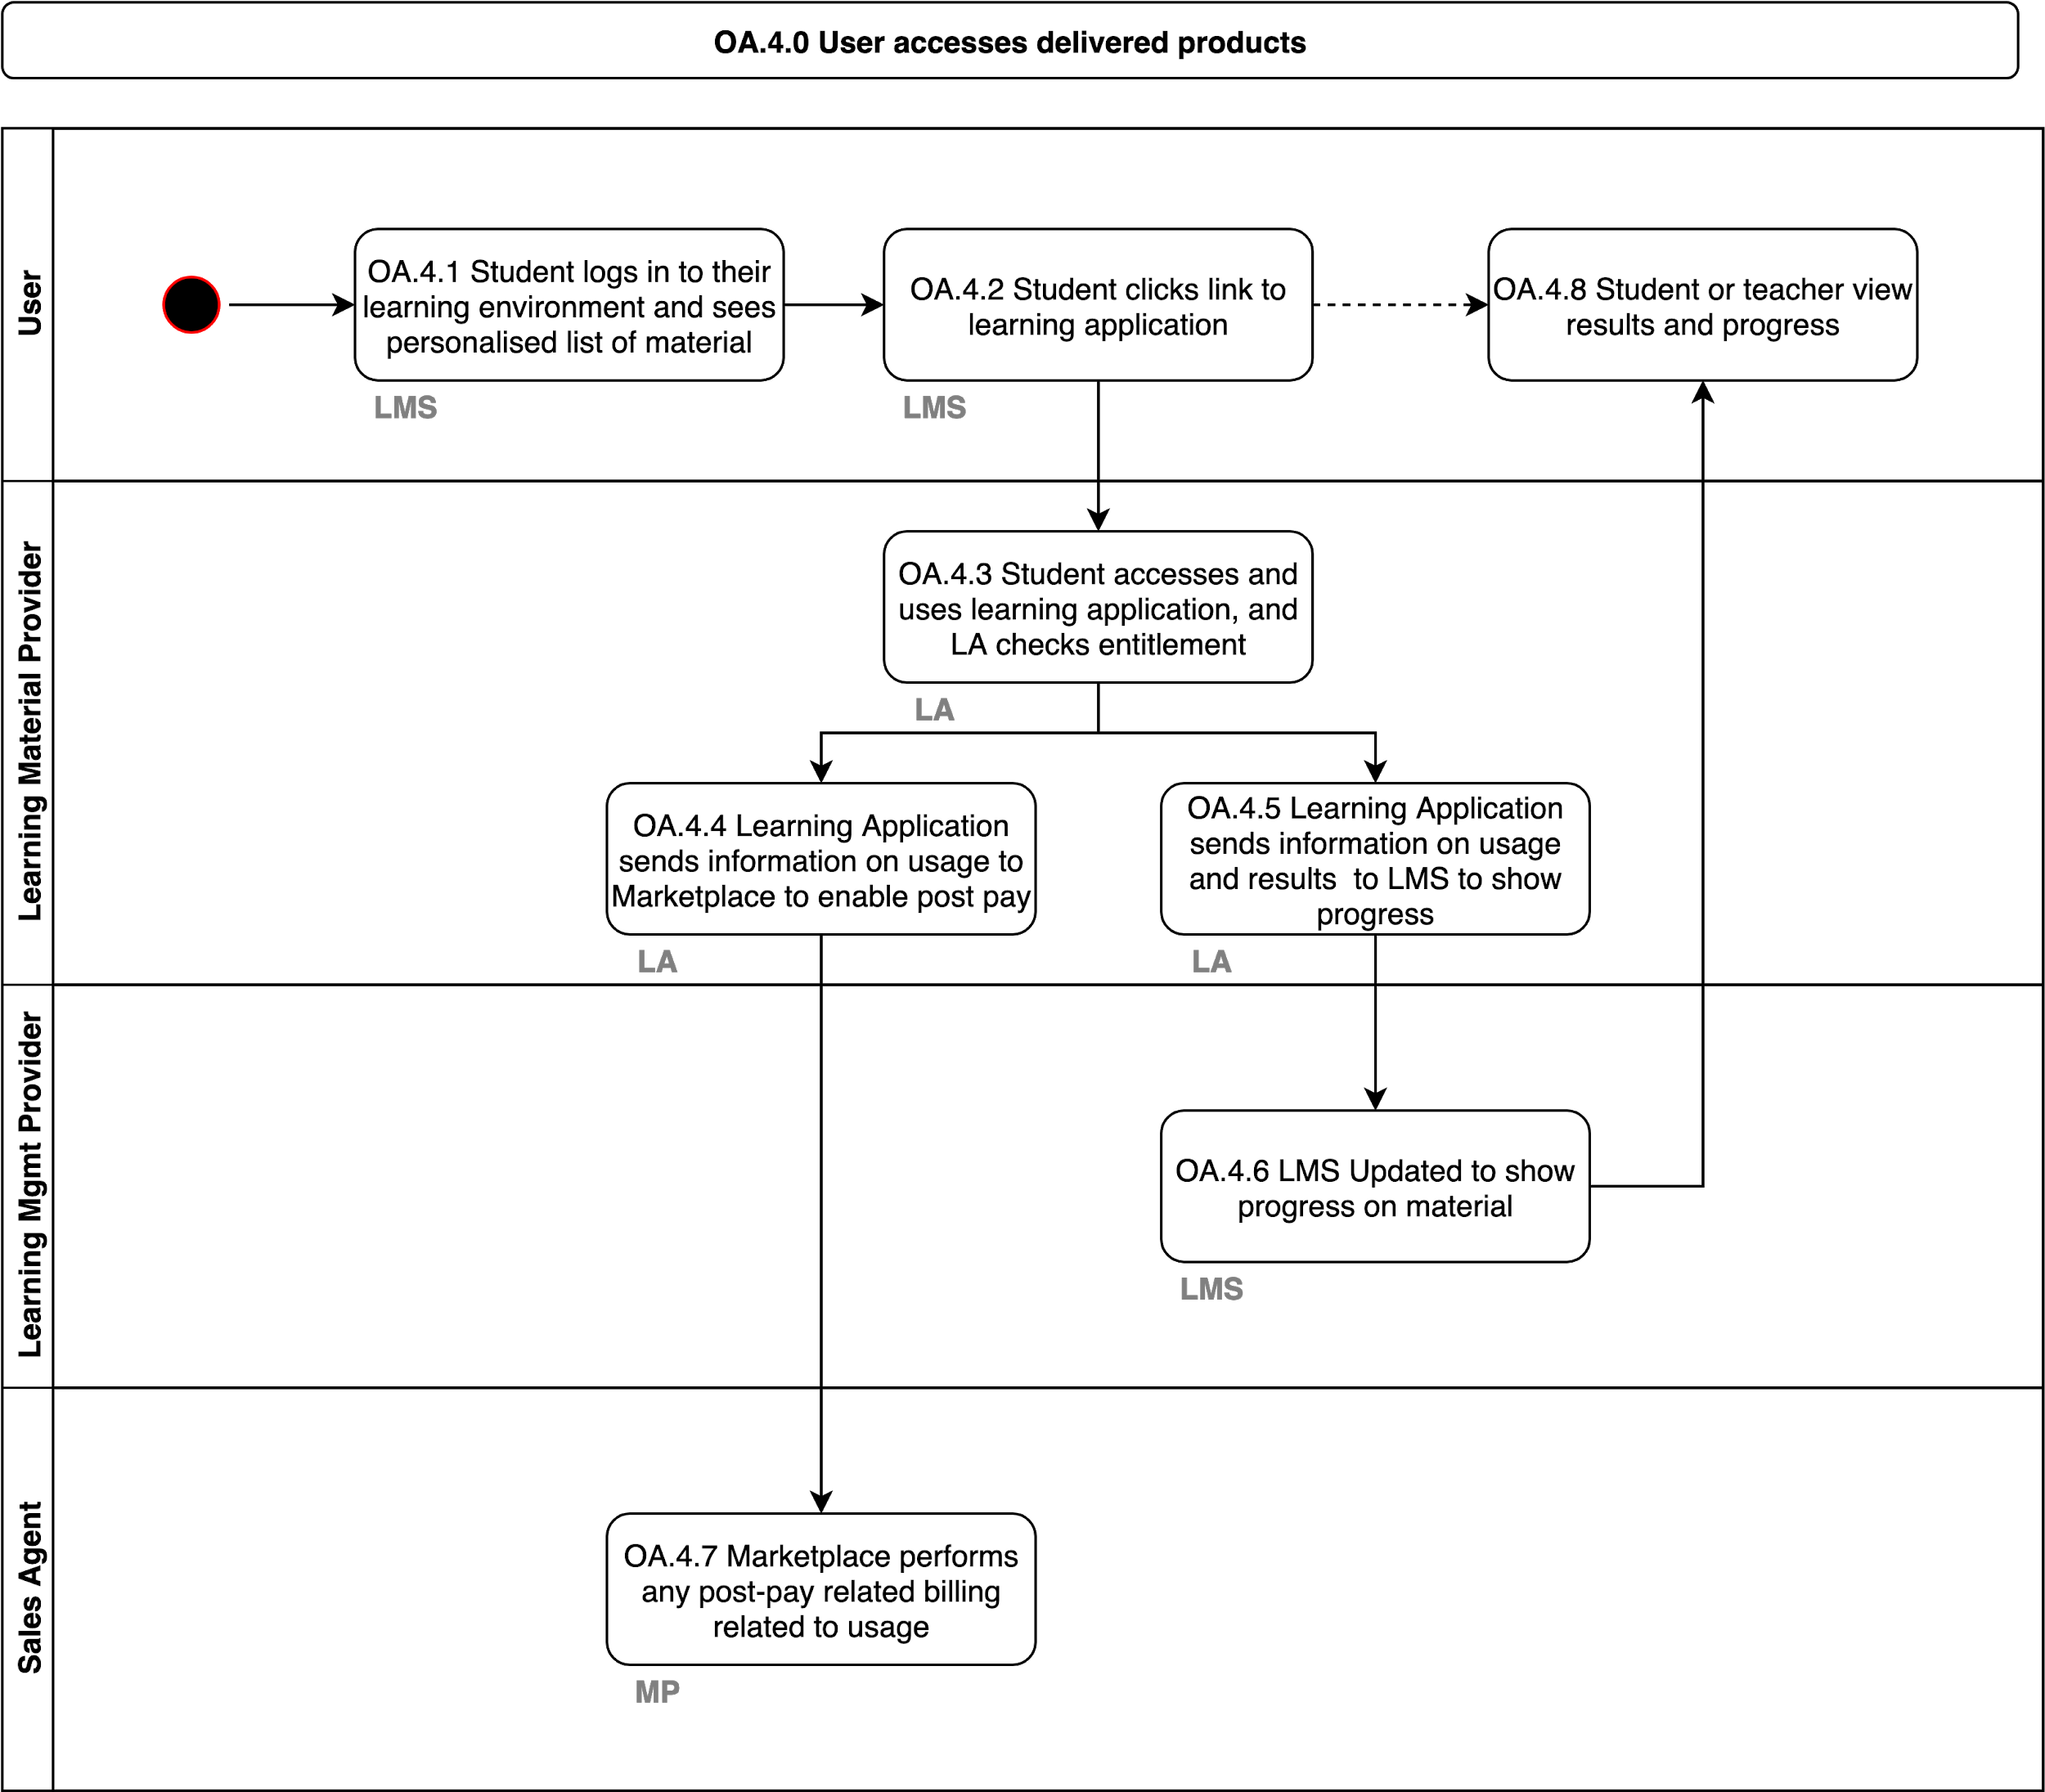](https://www.draw.io/?page-id=-477MPRmjyEfNg0dK3PI&scale=auto#G1DCkdewm8oO_kXXFjzAph-oT4X4u0k6Ig)

|  |  |  |  |
| --- | --- | --- | --- |
| **Step** | **Pre-requisites** | **Input Data** | **Output Data** |
| **OA.4.1** | Learning application uses an IdP that provides their identity to the LMS and LA |  |  |
| **OA.4.2** | Personalised learning list is available based on previous exchanges in OA.3 |  |  |
| **OA.4.3** | Entitlements are in place based on previous exchanges in OA.3 |  |  |
| **OA.4.4** | Learning Application is connected to Marketplace for school based on S.1 | Usage Data |  |
| **OA.4.5** | Learning Application is connected to Marketplace for school based on S.3 | Usage Data  Progress  Results |  |
| **OA.4.6** |  |  |  |
| **OA.4.7** | Payment models will be configured in advance based on S.1 |  |  |
| **OA.4.8** |  |  |  |

### 

### 

# OA.5.0 Buyer purchases additional products during school year

This model enables buyers to purchase additional material at any time during the school year (administrator, LMC, teacher, student or parent). This also enables any of the participants (e.g. the Learning Mgmt Provider or the Learning Application Provider) to also trigger an additional purchase event and direct the user to a Marketplace used by the school to complete the transaction (if needed). This is just one example of potentially many flows that could occur related to optional or additional material purchased or accessed during the school year

[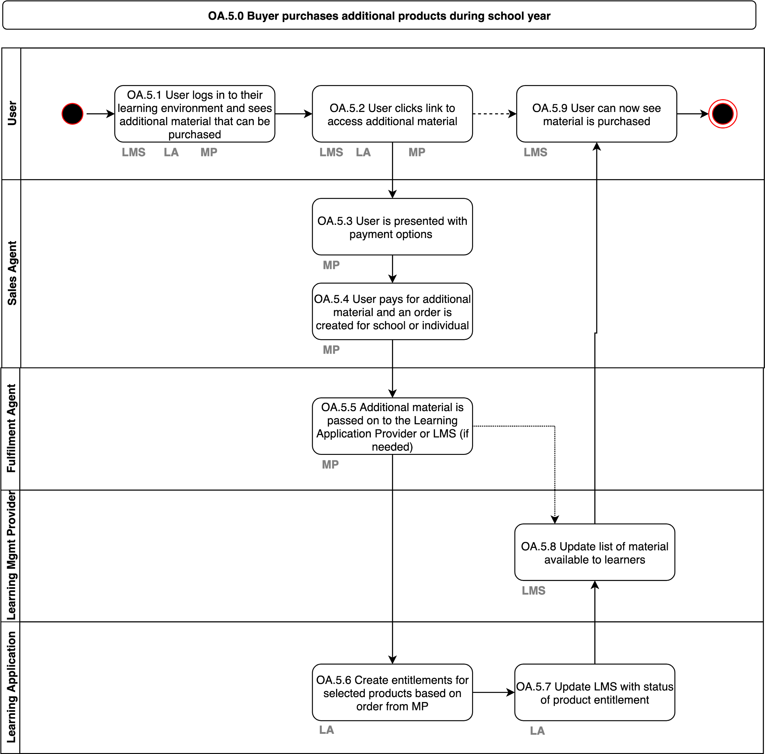](https://www.draw.io/?page-id=ljCEmyHFNI95sve2a-2U&scale=auto#G1DCkdewm8oO_kXXFjzAph-oT4X4u0k6Ig)

|  |  |  |  |
| --- | --- | --- | --- |
| **Step** | **Pre-requisites** | **Input Data** | **Output Data** |
| **OA.5.1** | School uses an IdP that provides their identity to the LMS, MP and LA |  |  |
| **OA.5.2** |  |  | Selected Product |
| **OA.5.3** | Possible payment scenarios can be configured based on agreements in S.1. | Selected Product | Payment Option |
| **OA.5.4** | The user can select how to pay for the product. | Selected Product  Payment Option | Purchased Product |
| **OA.5.5** | The Fulfilment Agent passes on information about the purchased product to the LMS or Learning Application | Purchased Product | Purchased Product |
| **OA.5.6** | The Learning Application can ensure entitlements exist for the products purchased. | Purchased Product | Entitlements |
| **OA.5.7** | The Learning Application provides updated information on fulfilment to the LMS. |  | Fulfilment Confirmation |
| **OA.5.8** | The LMS can update the status of the products to indicate they can now be used. | Fulfilment Confirmation | Updated Personalised Learning Materials List |
| **OA.5.9** |  |  |  |

### 

### 

# Assumptions on Technology Approach

* User and Application Authentication, via OpenID-Connect (or Oauth 2.0) and include ECK-ID
* School data will be based on RIO
* Service implementation will be via JSON / REST with optional GraphQL endpoints
* Where standards exist we should use them, however we should ensure they are modernised so that the ecosystem can thrive for the next decade
* All endpoints should have open source reference implementations in common languages to enable participants to quickly implement
* Publication of data (if needed) will be via registration of webhooks
* Application to Application authorisation will be performed through Administrators authorising access as part of an onboarding flow (either for SIS implementation, LMS implementation, or Digital Fulfilment) using the same OpenID-Connect identities for the administrators
* Audit & compliance procedures will be implemented to safeguard trust and accountability
* Data quality standards and procedures will be agreed upon to ensure smooth integration between services

Standards will be regularly updated to reflect continuous modernization following changing technology standards in order to prevent vulnerabilities from outdated practices. Governance is required to guide and inform these standards

# 

# Glossary of terms

|  |  |
| --- | --- |
| **Term** | **Definition** |
| LMC | Leermiddelen co-ordinator |
| LML | Leermiddelen lijst |
| LAS | Leerling Administratie Systeem |
| LMS / ELO | Learning Management System |
| LA | Learning Application |
| IdP | Identity Provider for Single Sign On (SSO) |
| School Catalogue | Aggregated catalogue for a school created based on the contract that the school has signed with a Sales Agent. |
| OIDC | OpenID-Connect access and approval flow to enable access to API’s from one service to another |

# Appendix A – Additional requirements Vocational Education

Just to keep in mind some of the differences that exists between Secondary Education and Vocational Education.

* Most (not all) licenses are ordered per person, not in bulk
* Licenses payment is done individually
  + But the person who pays may differ from the user (in case of an individual buy that is also true for secondary education)
* Schools are required (by law) to pay for exam-licenses for their students so schools do order licenses
* Products are ordered throughout the year with peaks in August and February and are expected to be delivered in 24 hours
* There is no real school season anymore like secondary education, so licenses commonly do not have a set start and end date, they just have a license duration for a number of days or for a cohort.
  + Licenses can be valid throughout summer vacation.
* Schools can be a lot bigger in number of students
* There are returning student to a school: they take a course, and are absent for months (even years) and return to the school for the same or a new course
* There is a big variety in LML, there are hundreds per school and sometimes multiple per course.
* It is common that other items than books and licenses are on a LML, for example tools and work gear.
* Students switching schools is more common
  + Because the students own the licenses, they want to use their license in the new school or buy a new license and use their previous results/work. So licenses and results are sometimes moved to a new account.